PULTENEY BRIDGE

BRIDGE

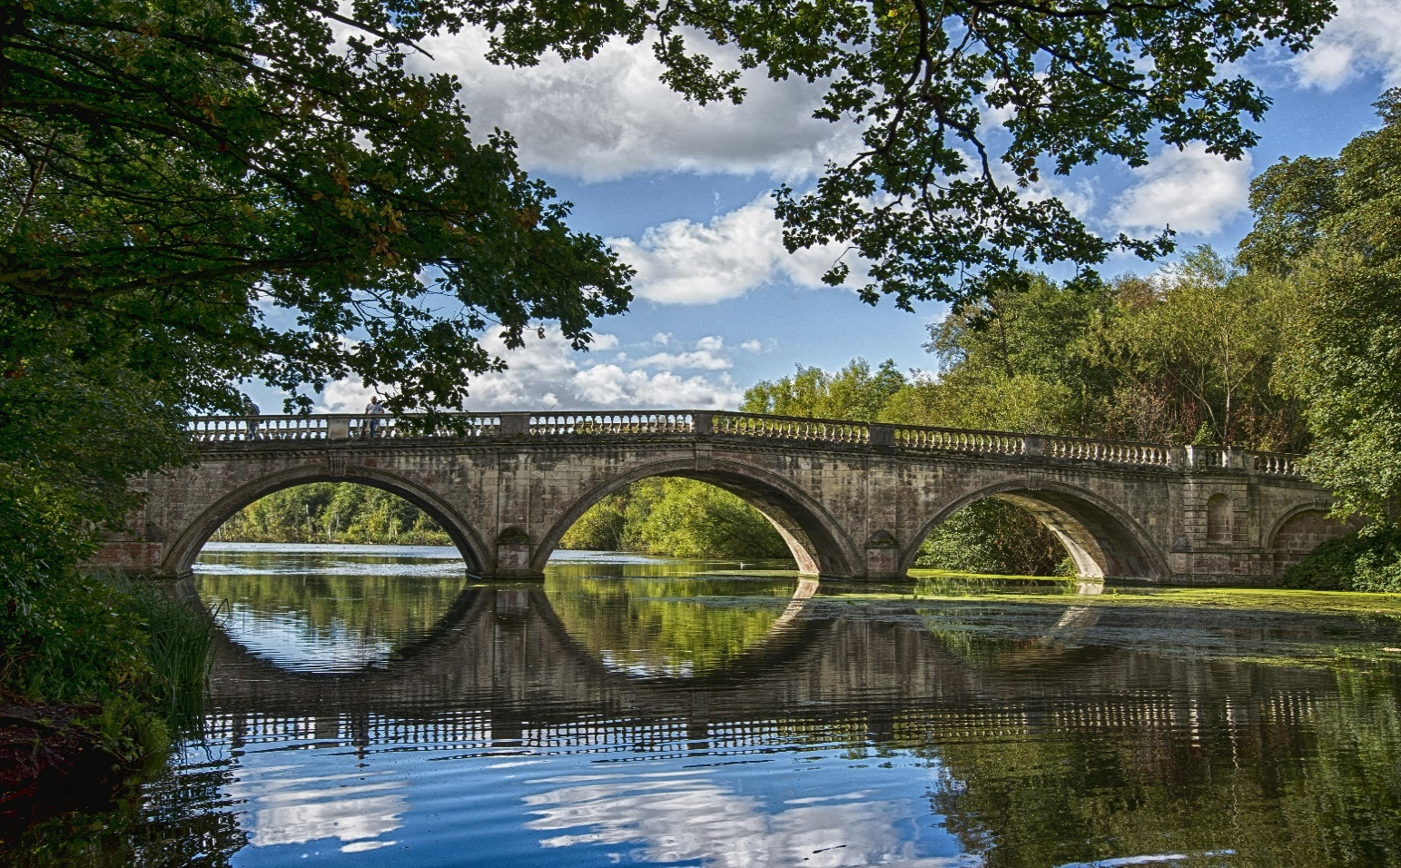

Pulteney Bridge, a historic marvel located in the heart of Bath, England, is a magnificent example of Georgian architecture and engineering ingenuity. Designed by Robert Adam and completed in 1774, it spans the River Avon, connecting the city center with Bath wick on the opposite bank. Named after Frances Pulteney, the wife of the bridge's commissioner, William Johnstone Pulteney, the bridge is renowned for its unique design and picturesque setting.

Pulteney Bridge is characterized by its distinctive horseshoe-shaped weir, which forms a cascading waterfall beneath the bridge, creating a scenic backdrop that has inspired artists and poets for centuries. The bridge itself is lined with elegant shops and residences, their Georgian facades reflecting in the tranquil waters below, adding to the bridge's charm and character.

Constructed of Bath stone, a honey-colored limestone characteristic of the region, Pulteney Bridge exudes timeless elegance and sophistication. Its three graceful arches span the river with effortless grace, while a series of balustraded walkways provide pedestrians with panoramic views of the surrounding landscape.

Beyond its aesthetic appeal, Pulteney Bridge holds significant historical and cultural significance for the city of Bath. It stands as a symbol of Bath's prosperity during the Georgian era, when the city flourished as a fashionable spa destination and center of social life. Today, the bridge remains a vibrant hub of activity, with bustling shops and cafes attracting visitors from around the world.